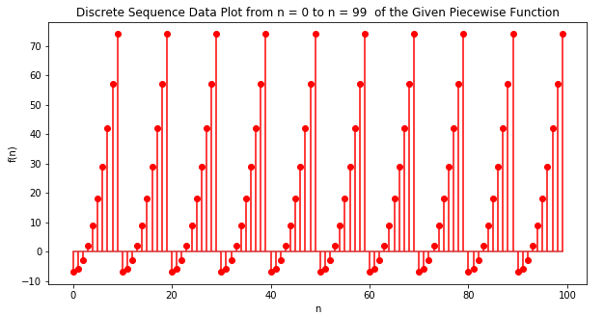

Comments on the graph $f\left(n\right)$:

The graph repeatedly shows the result of $f\left(n\right)=n^{2}-7$ if $n≤9$. That is due to the fact that the result of the piecewise function when $n≥10$ is $f(n-10)$ which means that $n$ will be repeatedly subtracted by 10 until $n<10$, which will make it satisfiable to the first subfunction $f\left(n\right)=n^{2}-7$ and thus undergo the mathematical operation described by that function as well. Since the stem() command was used in graphing the piecewise function, only the discrete results of that function are shown and all results with a decimal part are excluded. In addition, the graph shows that from $n=0$ up to $n=99$, the highest achieveable discrete result from the piecewise function is 74, which occurs whenever $n$ has the number 9 as its last digit. And that the lowest achieveable discrete result is -7, which occurs whenever $n$ has the number 0 as its last digit.